**Math 155, *Lecture Notes- Bonds* Name____________**

***Section 10.4*** *Polar Coordinates and Polar Graphs*

Now that we can graph parametric equations, we can study a special parametric system called the **polar coordinate system**. To form the polar coordinate system in the plane, we fix a point , called the pole, or origin, and construct from  an initial ray called the **polar axis**, as shown below. Then each point  in the plane can be assigned polar coordinates , as follows.



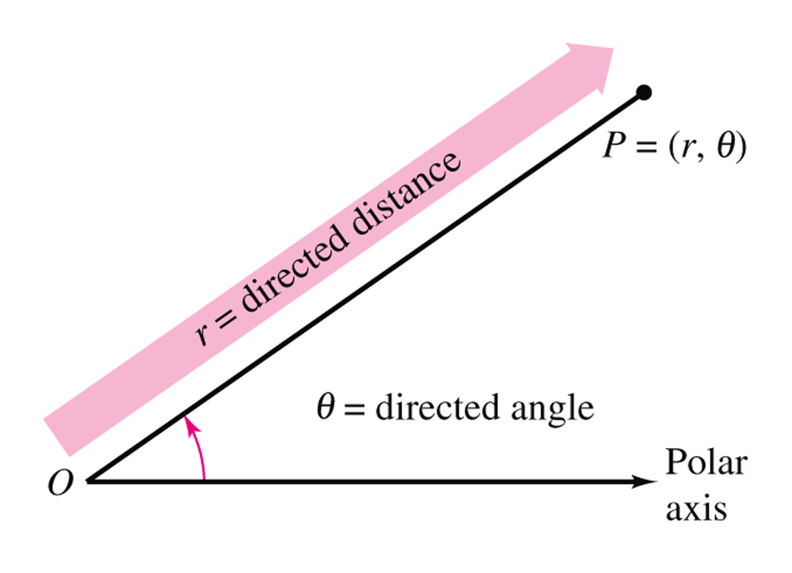 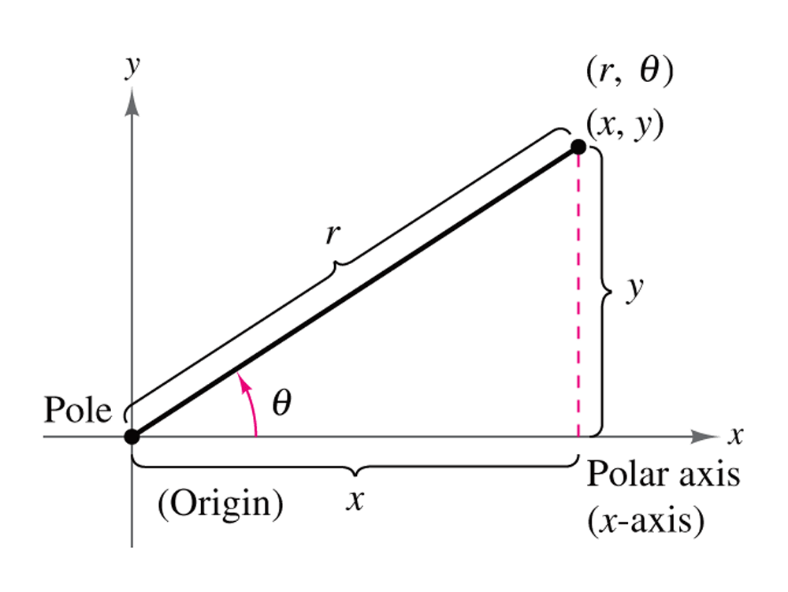

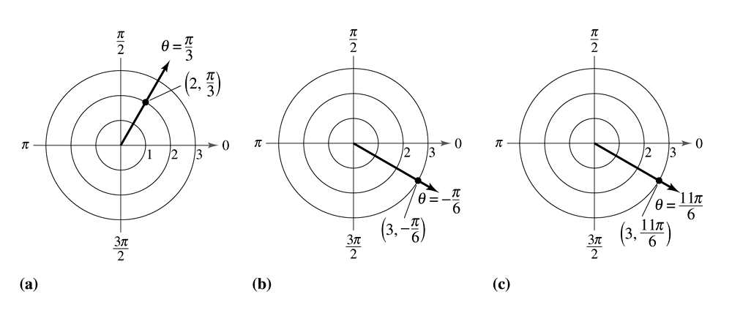

With rectangular coordinates, each point  has a unique representation. This is not true with polar coordinates. For instance: , or , where *n* is any integer. In fact, the pole can be represented by , where  is any angle.

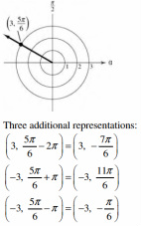 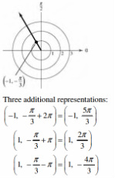 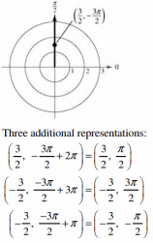

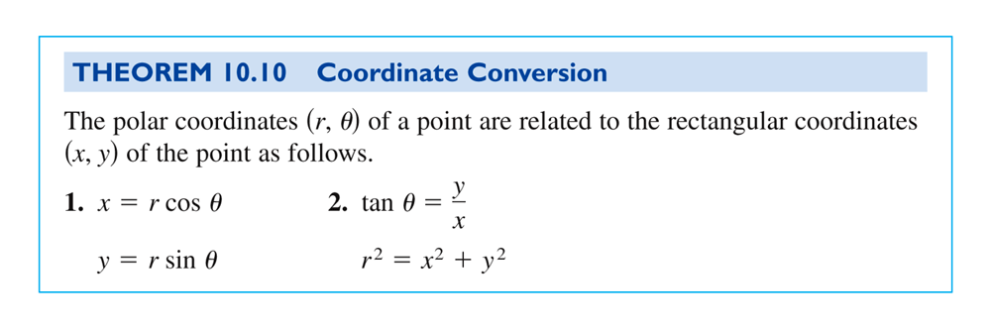

**Ex. 1:** Convert  in rectangular coordinates to polar coordinates.

**Ex. 2:** Convert the equation  from polar coordinates to rectangular coordinates and sketch its graph.

**Ex. 3:** Convert the equation  from rectangular coordinates to polar coordinates and sketch its graph.

**Ex. 4:** Draw the graph of  and complete the table.

|  |  |  |  |
| --- | --- | --- | --- |
|  |  |  |  |
|  |  |  |  |
|  |  |  |  |
|  |  |  |  |
|  |  |  |  |
|  |  |  |  |
|  |  |  |  |
|  |  |  |  |
|  |  |  |  |
|  |  |  |  |
|  |  |  |  |
|  |  |  |  |
|  |  |  |  |
|  |  |  |  |
|  |  |  |  |

**Ex. 5:** Draw the graph of  and complete the table.

|  |  |  |  |
| --- | --- | --- | --- |
|  |  |  |  |
|  |  |  |  |
|  |  |  |  |
|  |  |  |  |
|  |  |  |  |
|  |  |  |  |
|  |  |  |  |
|  |  |  |  |
|  |  |  |  |

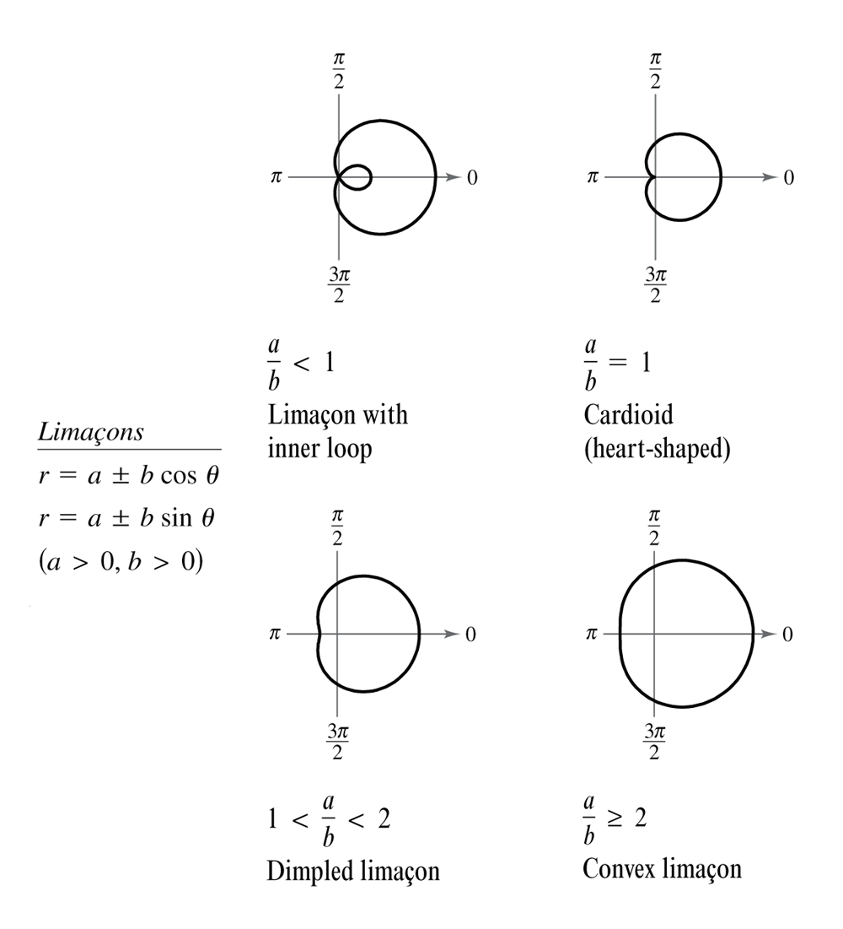

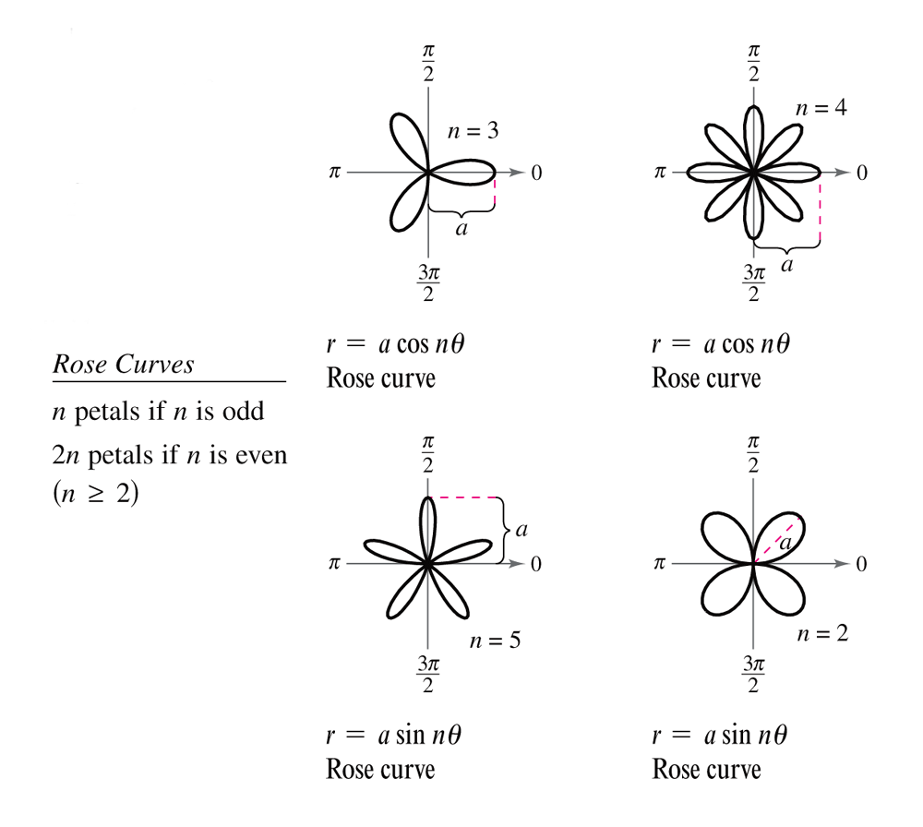

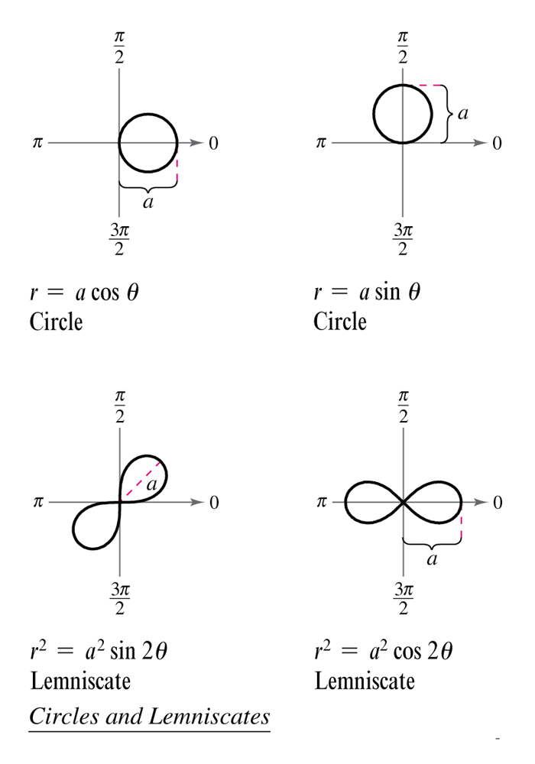

We can use the parametric form of  to establish the polar form of the derivative. This will allow us to find the slopes of tangent line at particular points on polar curves.

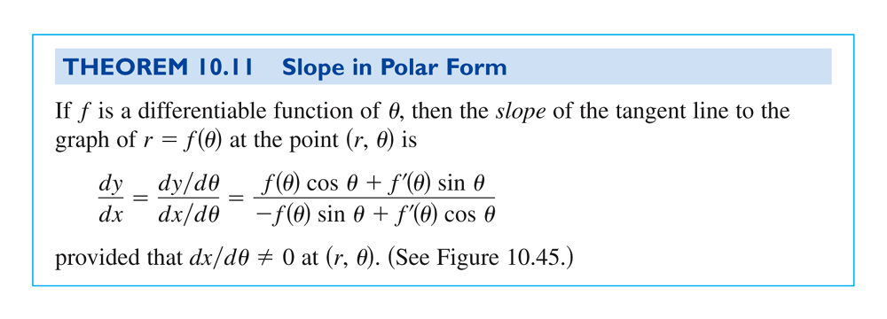

**Ex. 6:** Find  and the slopes of the lines at the given points for the given curve:  at **A**. , **B**. , and **C**. .

**More Ex. 6:**

**Ex. 7: (a)** Use a graphing utility to draw the graph of  and complete the table. **(b)** Use a graphing utility to draw the tangent line at .

**(c)** Find .

|  |  |  |  |
| --- | --- | --- | --- |
|  |  |  |  |
|  |  |  |  |
|  |  |  |  |
|  |  |  |  |
|  |  |  |  |
|  |  |  |  |
|  |  |  |  |
|  |  |  |  |
|  |  |  |  |

**More Ex. 7:**

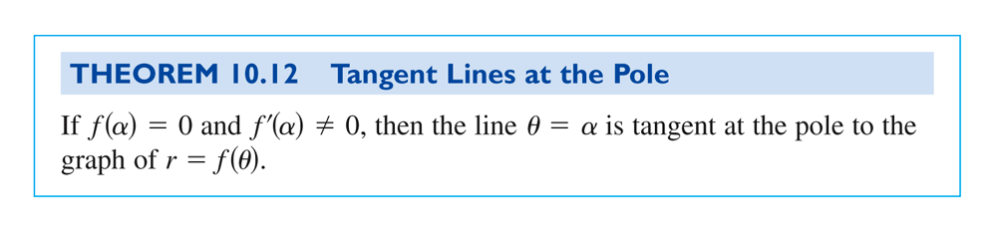

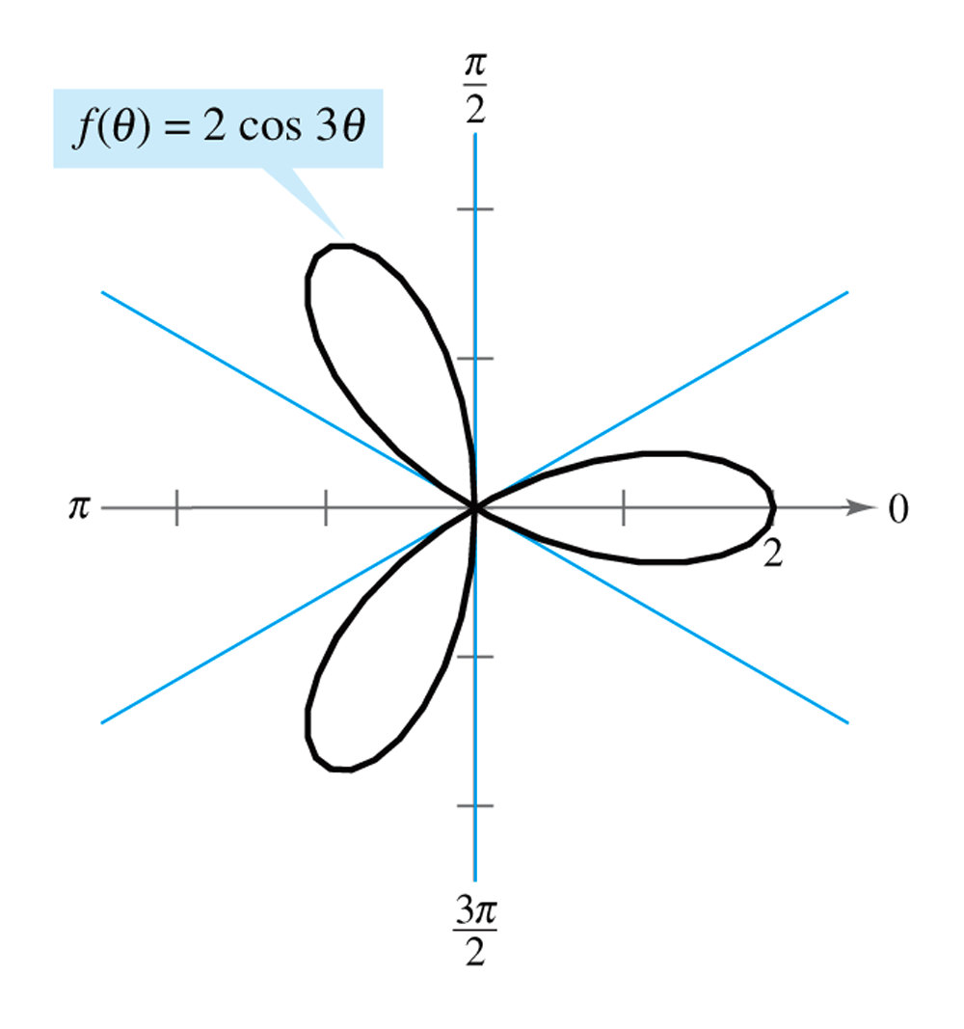

**Ex. 8:** Sketch the graph of  and find the tangents at the pole.

*Polar System Grids:*

